DIS-Pac-Poly-HI- Menehune-0-700 CE

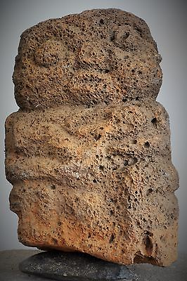**Hawai'ian *menehune* carved in vesicular lava, ca. 0 to 700 CE**

**Hawai'ian *menehune* carved in vesicular lava, ca. 0 to 700 CE, the oldest figure of a menehune yet discovered, since it precedes the later waves of migration to the Hawaiian Islands at the end of the Neo-Atlantic Altithermal period ca. 1200 CE. 15 in. high. For comparison, there is smaller vesicular lava head from Necker Island dated to the same period now in the Metropolitan Museum, New York. This *menehune* holds an indistinct object possibly a lava knife used in human sacrifices, such as those practiced at the sacrificial site of Mo'okini in Kohala on the island of Hawaii. The figure appears to be male. The ghosting of a natural red pigment is present on the surface where the lava knife is depicted, possibly applied to this human figure during sacrificial ceremonies.**

**Excellent condition.**

# Paleontological evidence for Homo floriensis on the island of Flores in Indonesia provides evidence for a small-bodied hominin proportionately equivalent to hominins that coexisted with Homo sapiens for some millennia on isolated islands such as Flores and the Hawai'ian Islands providing the basis for the mythic *menehune* or "little people". Hominins such as Homo floriensis may represent sub-species of Homo sapiens who have undergone endemic dwarfism owing to their genetic isolation. See Dixon P. W. 2004. The Hawaiian Menehune in myth and paleontology, *Human Evolution* (19: 4, 287-291).

**Additional References**

1. **Brown P., Sutikna T., Morwood M.J., Soejono R.P., Jatmiko Saptomo E.W., Rokus A.P. 2004. A new small-bodied hominin from the Late Pleistocene of Flores, Indonesia, Nature (140, 7012, 431, 1055–1061).**
2. **Bruner E. 2004. Evolution, actuality and species concept, a need for a paleontological tool, Human Evolution (19:2, 93–112).**
3. **Colum P. 1924. At the Gateway of the Day. New Haven: Yale University Press, p. 156.**
4. **Kingsley P. 1998. In the dark places of wisdom, Parabola (3:4, 40–46).**
5. **Metzeger B. 1929. Tales told in Hawai'i. New York: Frederick A. Stokes Company, p. 97.**
6. **Morwood T., Soejuno R.P., Ruberts R.G., Sutikna T., Turney G.S.M., Westway K.E., Rink W.J., Zhao J.X., Von den Bergh G.D., Rokus A.P., Hobbe D.R., Moore M.W., Bird M.L., Fifleid L.K. 2004. Archeology and age of a new hominin from Flores, in eastern Indonesia, Nature (140: 7012, 431, pp. 1087–1091).**
7. **Pûku'i, M.K. 1994. The water of Kâne. Honolulu: The Kamehameha Schools Press, pp. 65–72.**
8. **Westervelt, W.D. 1926. Hawaiian historical legends. New York: Fleming H. Revell Company, p. 39.**
9. **Wheeler, P. 1953. Hawaiian wonder tales. New York: The Beechurst Press, p.224.**